Strange Sid results that may correspond to cosmic ray detector count drop
SID Samples AHSCincy Feb 17th-20th
Notice strange readings February 18th and 19th. The data from the 19th looks like lightning storms except we had quiet weather from here to maine. Overcast and light rain/light snow. May have been weather related. No other monitors picked up anything significant during the same time period.
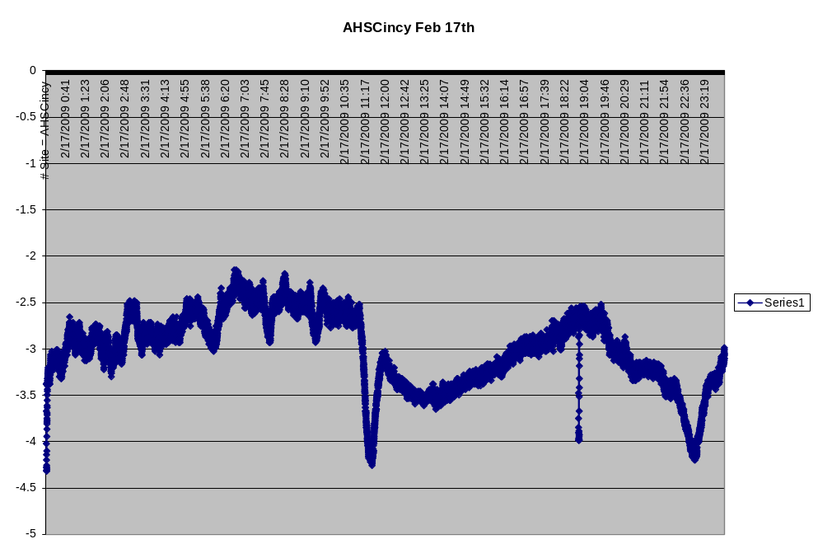
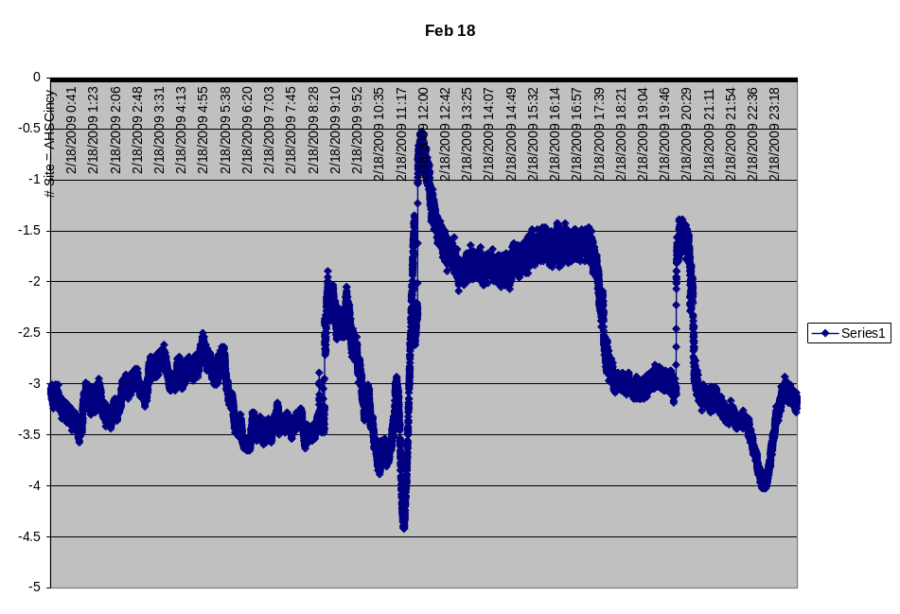
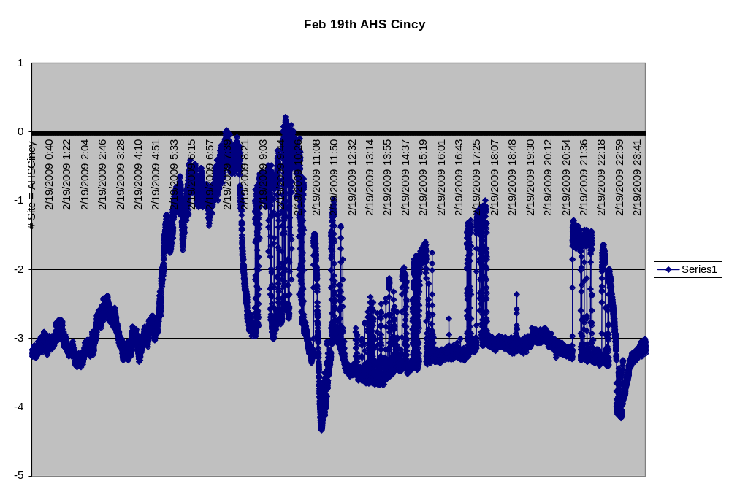
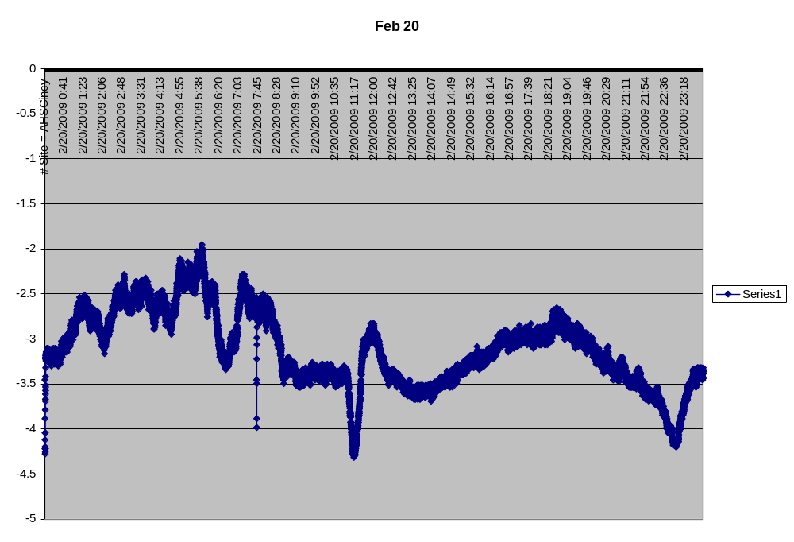

Cosmic ray flux study at with 2 counters 46 cm apart in 2 coincidences angled at 30 degrees towards the south. The group was trying to determine if pointing the counters at the sun would change the cosmic ray flux while the sun passed through the geometry the detector. They had actually done the study back in December and wanted to run a couple of days before I returned the detector to see if there were any changes. Currently the detector is in the same configuration to check if this was a one time occurrence or something that happens when the detector is kept at an angle.
Cosmic ray counts drop off to almost zero for 4 minutes at 2030 hours



